Asia-China-Mirror- Han-Cao Ye-Sothebys

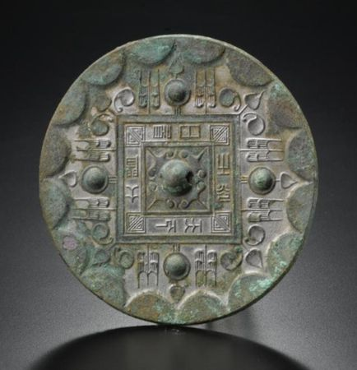

A Bronze 'Cao Ye' Mirror. Western Han Dynasty. Photo Sotheby's

the hemispherical boss enclosed by four trefoils extending to the corners of a square border cast with eight characters reading jian ri zhi guang, tianxia da ming (by the light of the sun the world is illuminated), in turn surrounded by a ring with four bosses alternating with stylized tree motifs and trefoils with concave leaves, all set within a raised border of semi-circles around the rim, the silvery patina with patches of encrustation. Diameter 5 1/2 in., 14 cm. Estimate 8,000-12,000 USD

 Property Of The Sano Art Museum, Mishima City,Shizuoka

NOTE: For a related example of this mirror type discovered in the tomb of Dou Wan, consort of Liu Sheng, Prince Jing of the Western Han kingdom of Zhongshan, compare Mancheng Han mu fajue baogao, Beijing, 1980, vol. 2, pl. 181: 1.